# Xilinx Vivado Installation and Startup Instructions

Fall 2019

1. **Vivado Download and Installation**

On the web, go to <https://www.xilinx.com/support/download/index.html/content/xilinx/en/downloadNav/vivado-design-tools/archive.html>

Scroll down and select 15.1

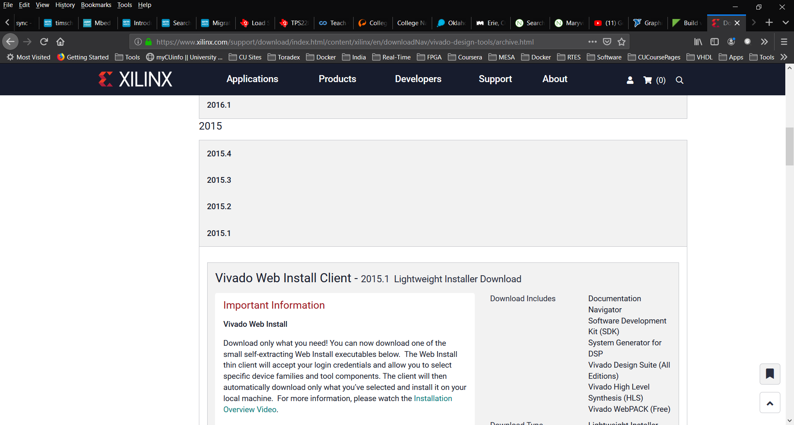

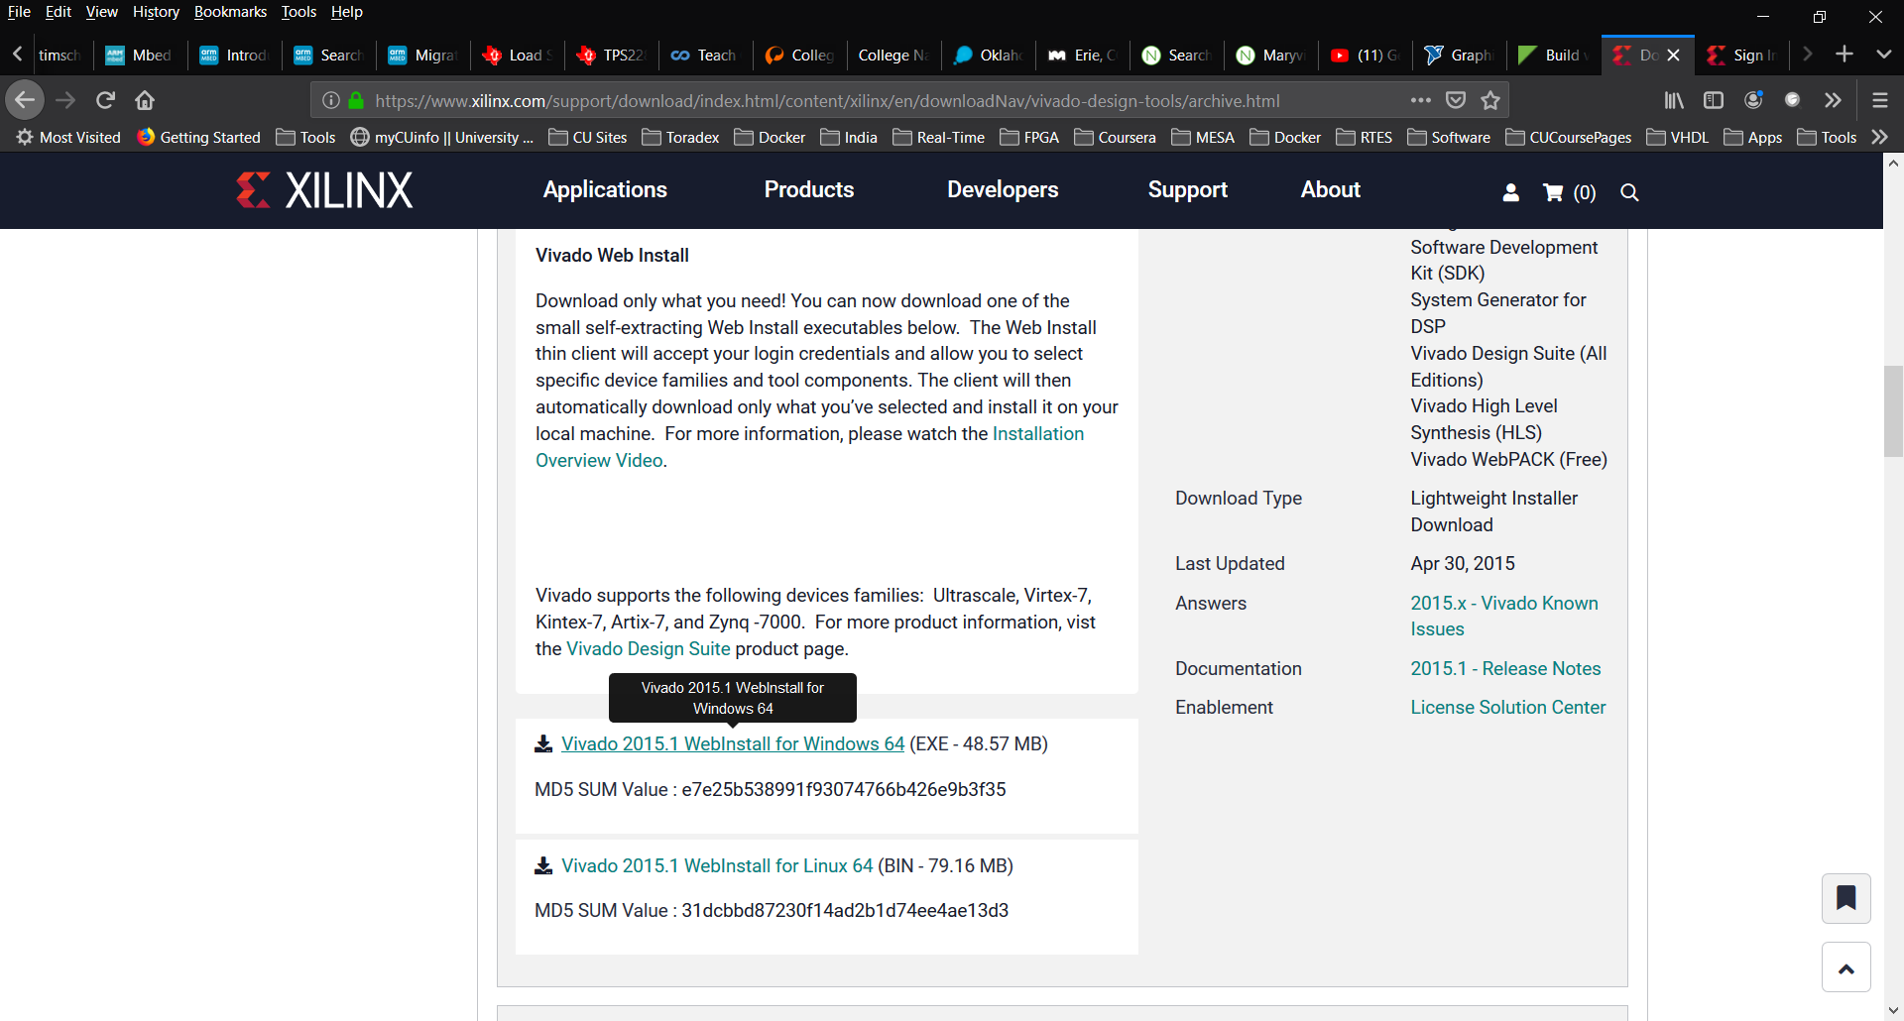

Select Vivado 2015.1 WebInstall

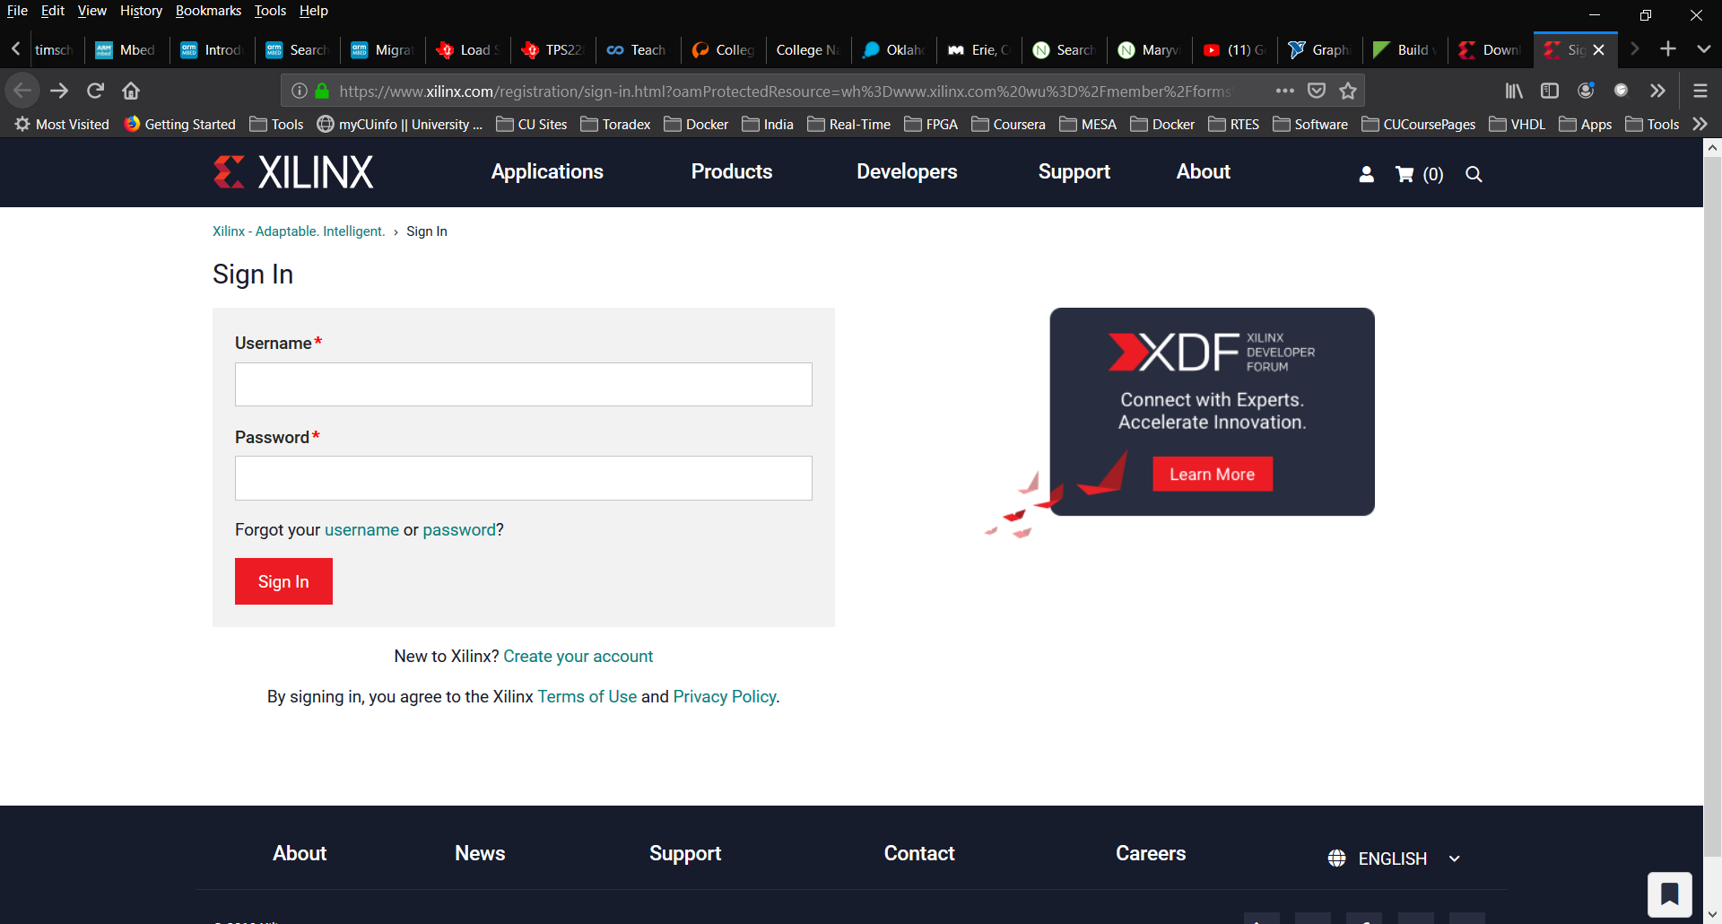

Sign In, or create an account if you don’t have one. Verify your status and you should see:

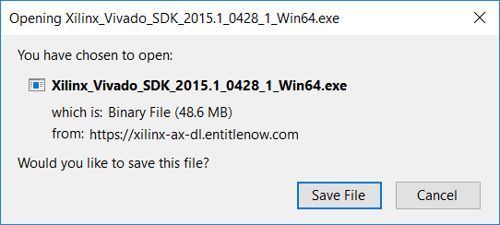

Save this file and run it.

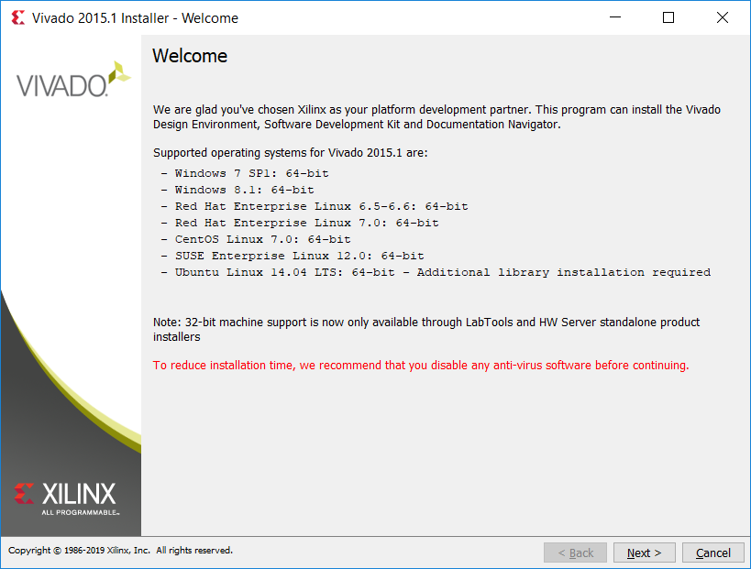

Click through all the authentication and license screens. Choose the WebPACK edition:

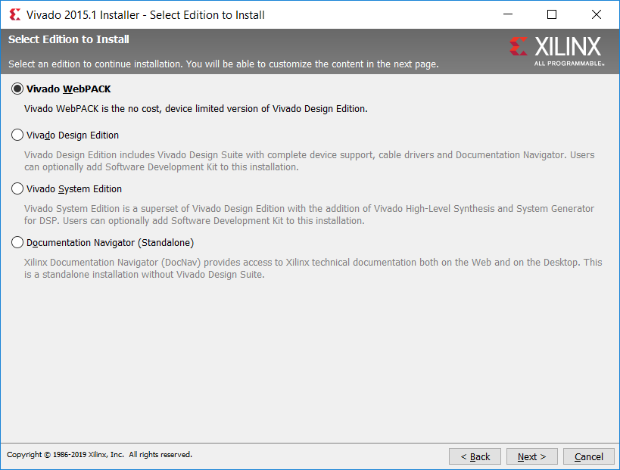

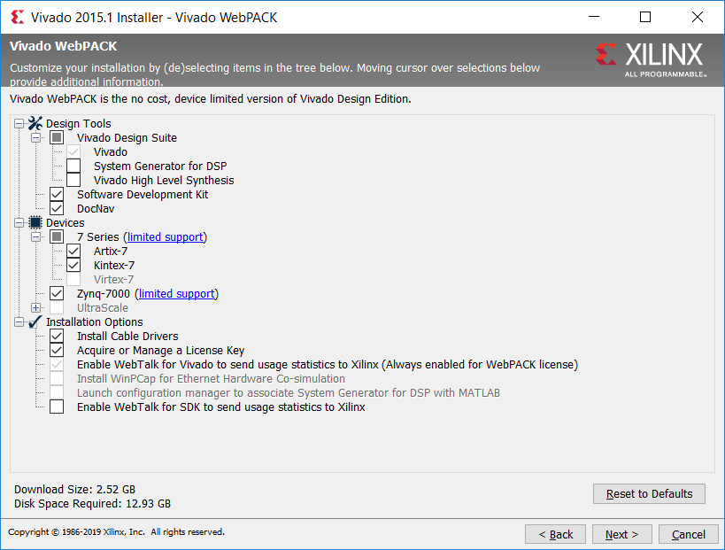

Use the default installation options.

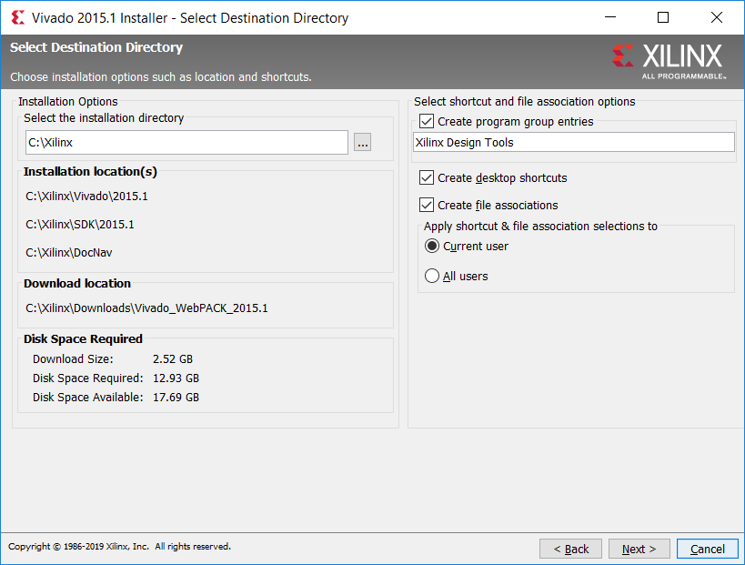

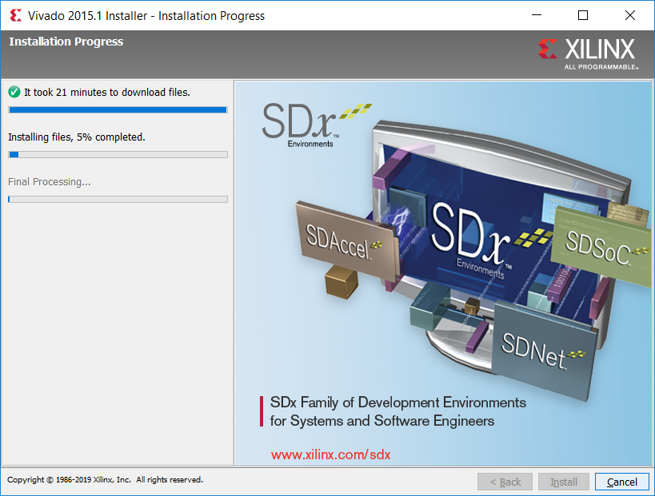

1. **Vivado Licensing**

After Installation is complete, select the free license:

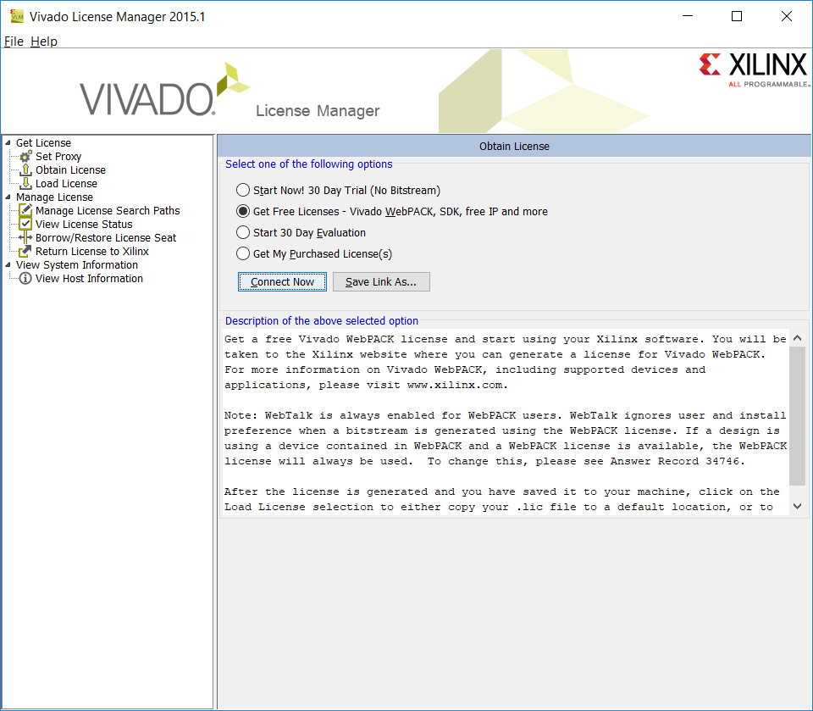

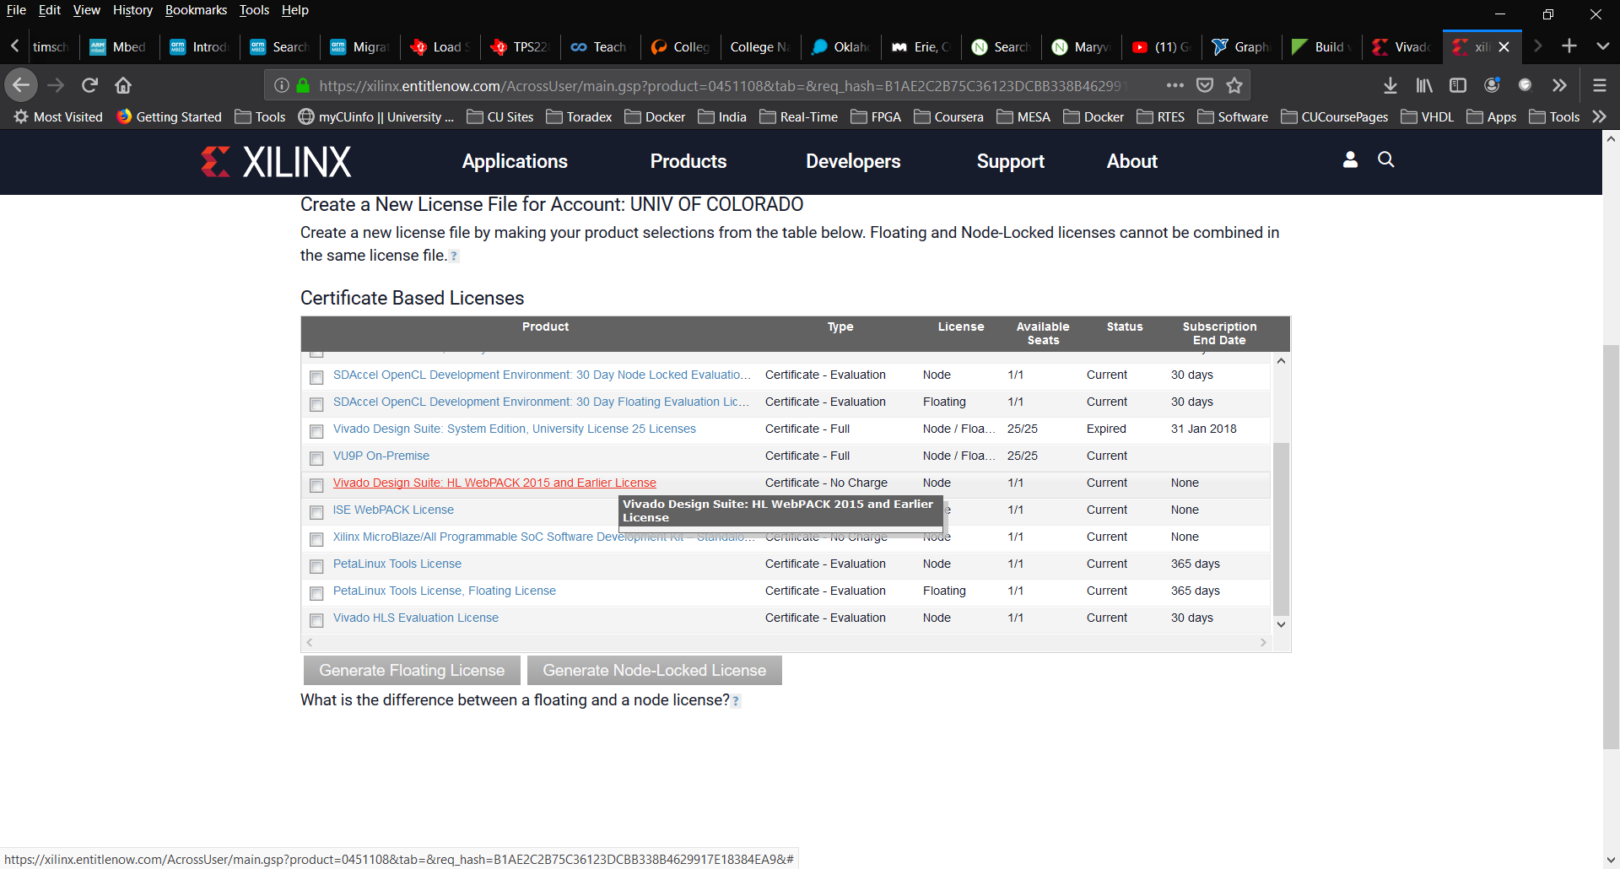

Once you finish this process, you should get a license file in an email.

1. Save the attached license file (.lic) to your desktop or some other folder on your computer

2.     Run the Vivado License Manager

Windows: Run ‘Manage Xilinx Licenses’ from underneath your Version group of the Xilinx Design Tools program group

Linux: Type ‘vlm’ in a command-line window

3.     Select the ‘Load License’ screen and click on the ‘Copy License…’ button

4.     Browse to the downloaded license file and click ‘Open’

You may need to run vivado directly, by executing the vivado.bat file in C:\Xilinx\Vivado\2015.1\bin.

You should see:

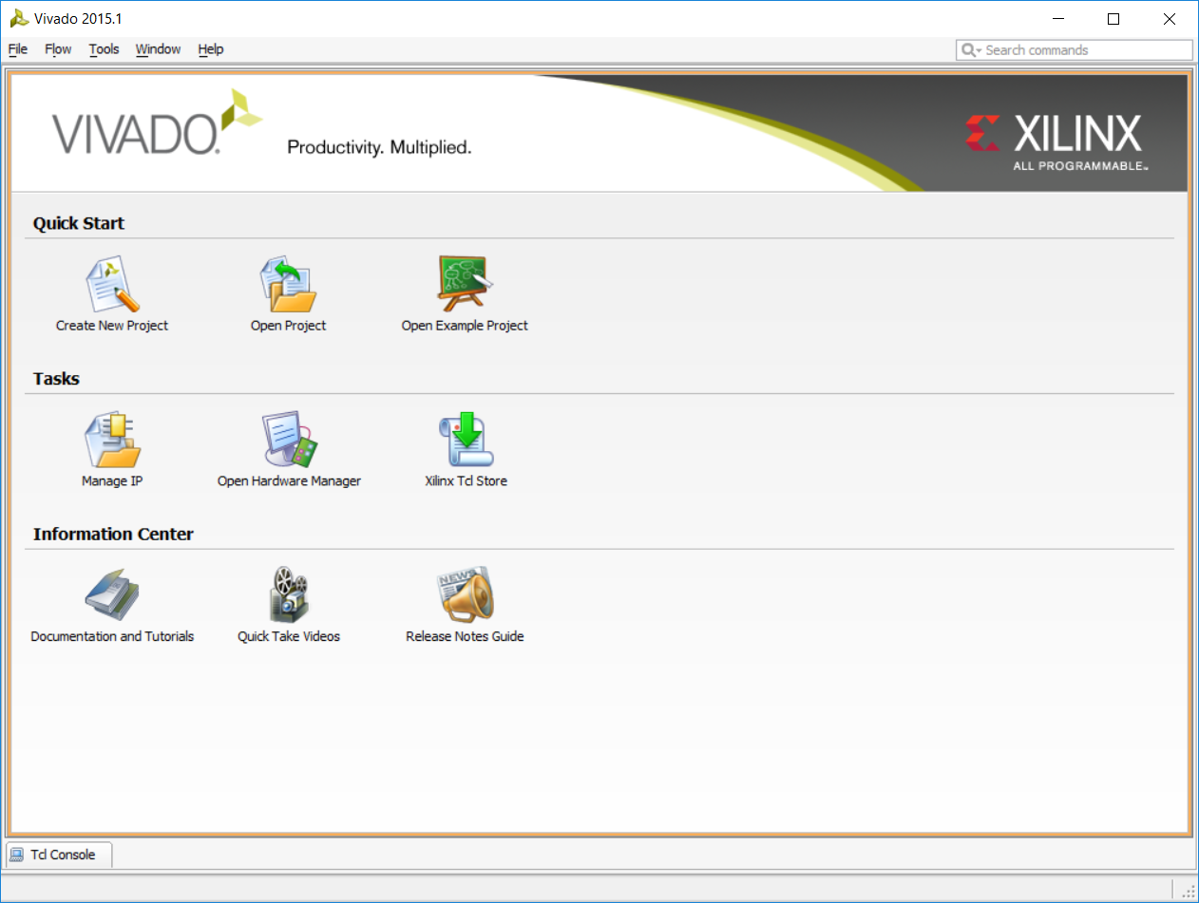

Troubleshooting:

Refer to

[https://www.xilinx.com/video/hardware/vivado-design-suite-installation-overview.html and see UG973](https://www.xilinx.com/video/hardware/vivado-design-suite-installation-overview.html%20and%20see%20UG973).

You may see these error messages:

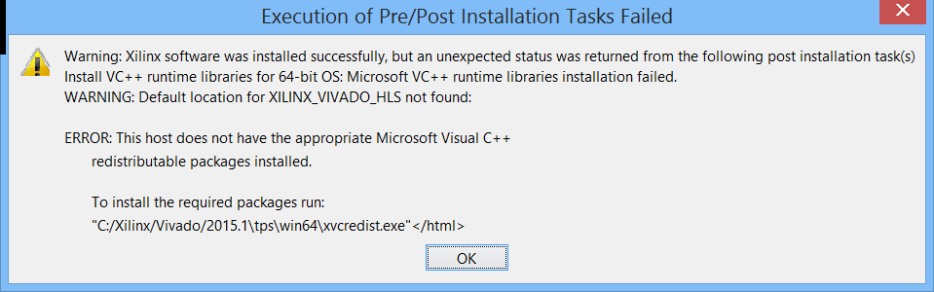

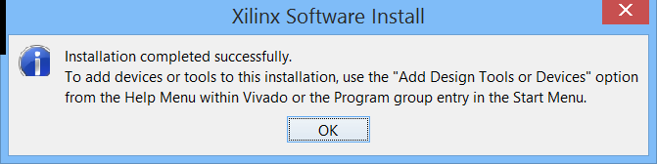

At this point downloaded the latest Visual C++ redistributable from Microsoft and ran it. It completed, asked for restart which I did. Then go this:

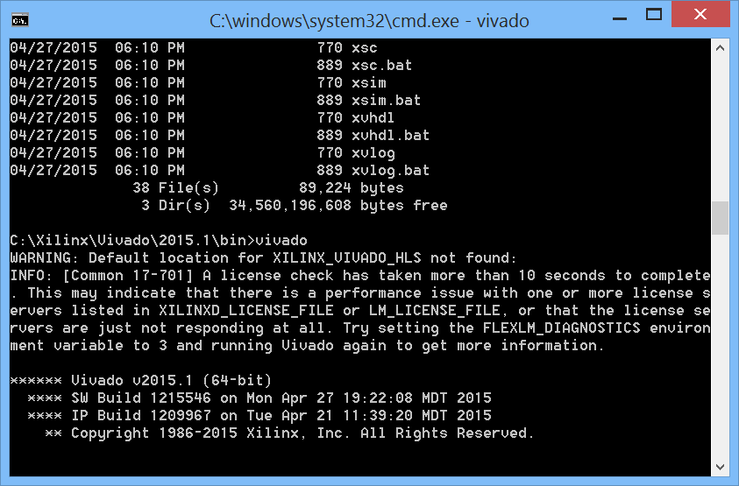

However Vivado does start.